**CAR PRICE PREDICTION WITH**

**MACHINE LEARNING**

**DATASET: CarPrice.csv**

**CODE:**

import numpy as np

import pandas as pd

import matplotlib.pyplot as plt

import seaborn as sns

from sklearn.model_selection import train_test_split

from sklearn.tree import DecisionTreeRegressor

data = pd.read_csv("C:/Users/User/Desktop/IRIS/CarPrice.csv")

data.head()

**Result:**

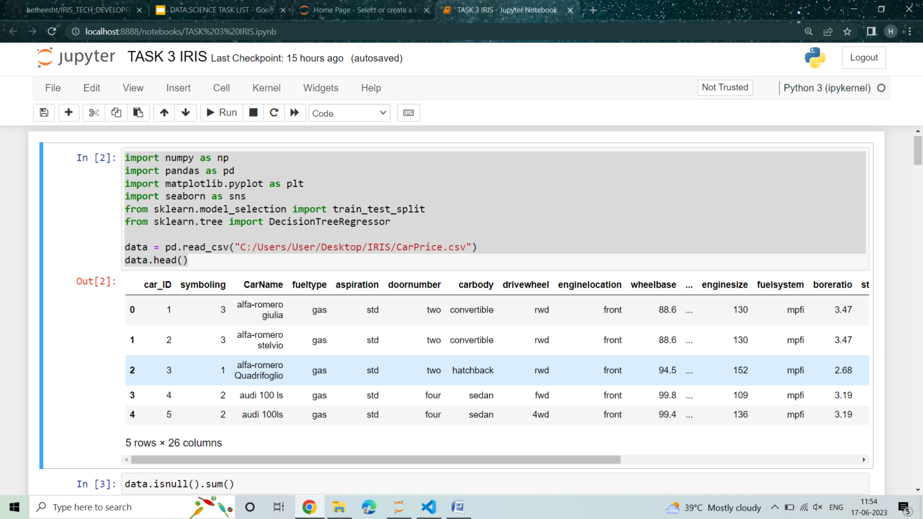

#Continue

data.info()

**Result:**

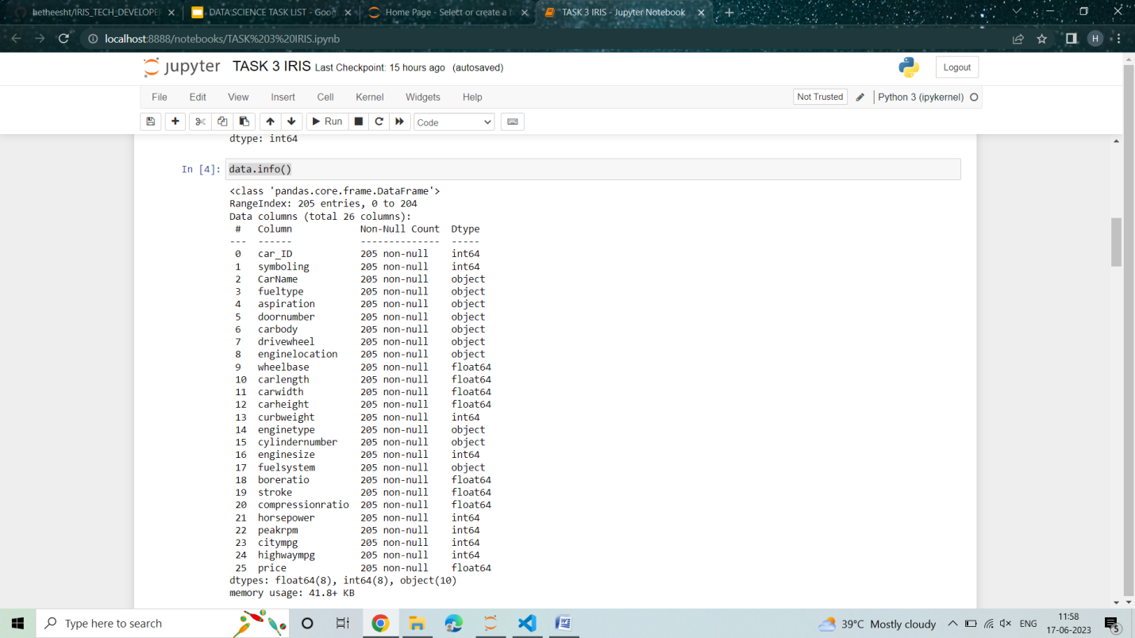

#continue

print(data.describe())

**Result:**

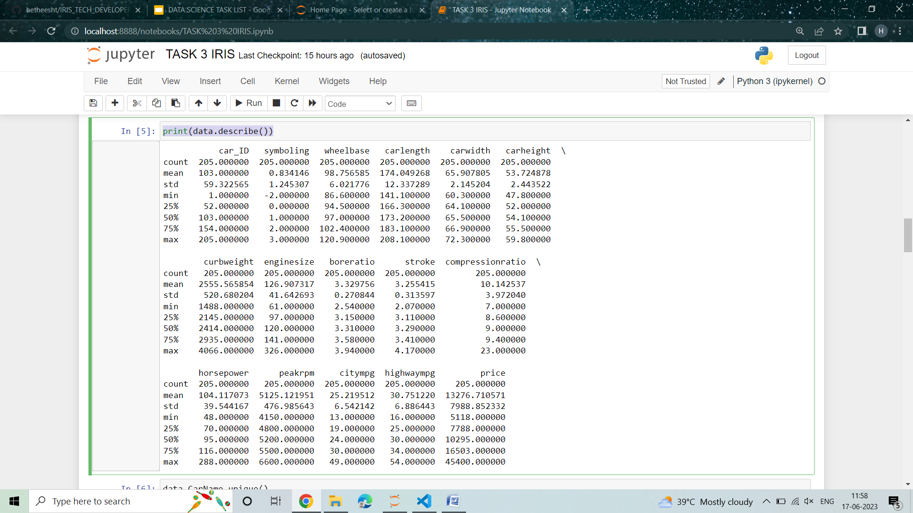

sns.set_style("whitegrid")

plt.figure(figsize=(2,2))

sns.histplot(data.price ,kde=True)

**plt.show()**

**Result:**

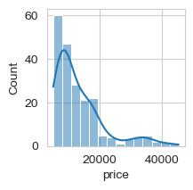

plt.figure(figsize=(20, 15))

correlations = data.corr(numeric_only=True)

sns.heatmap(correlations, cmap="coolwarm", annot=True)

plt.show()

**OUTPUT:**

